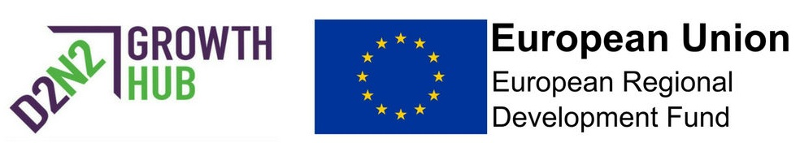

The D2N2 Business Investment Fund

The Growth Hub have an exciting new asset to add to the portfolio of support available to D2N2 businesses in the form of an investment fund.
Who can access the fund and what is it for?
The D2N2 Business Investment Fund is available to support small and medium sized enterprises with projects that will directly improve their productivity, efficiency or job creation. The fund will support projects such as digital developments, specialist consultancy and equipment purchases.
It is important to note that only applications that clearly show a step-change in the business activity will be supported. This grant will not support ‘new-for-old’ replacements.
What value is available?
Grants of between £3,500 and £20,000 are available and will contribute up to a maximum of 35% of the project costs.
There are a number of alternative funding options available within D2N2 and the D2N2 Growth Hub will work with you to establish which solution best meets your business needs.
How do businesses apply?
Applicants will need to adhere to a financial assessment, provide quotes for purchases and must defray expenditure before claiming the grant.
For further information and to apply for a grant please contact the D2N2 Growth Hub on 0333 006 9178 or email info@d2n2growthhub.co.uk where you will be allocated to a Business Adviser to discuss your project.

